A Project Report on

## “COMPUTERIZED EXAMINATION SYSTEM”

Submitted in Partial Fulfilment of the Requirements For the award of the degree

**Bachelor of Computer Applications OF**

**BENGALURU CITY UNIVERSITY**

**SUBMITTED BY**

**STUDENT NAME - RAHUL BABU Reg No - R1911677**



**DEPARTMENT OF COMPUTER APPLICATIONS**

**Bachelor of Computer Applications**

## PRESIDENCY COLLEGE, KEMPAPURA, HEBBAL

### Bangalore-560 024

**Session: OCT 2021-FEB 2022**

## PRESIDENCY COLLEGE

**DEPARTMENT OF COMPUTER APPLICATIONS**

**Bachelor of Computer Applications (Affiliated to Bengaluru City University) Kempapura, Hebbal, Bangaluru-560024**



CERTIFICATE

*This is to certify that* ***RAHUL BABU*** *with Register No.* ***R1911677*** *has satisfactorily completed the Fifth Semester BCA Project titled “Computerized Examination System”, as a partial fulfillment of the requirements for the award of the Degree in* ***Bachelor of Computer Applications****, B****engaluru City University****, during the Academic Year* ***2021– 22****.*

##### Project guide Head of Department

(Department of computer Application)

**Examiners Reg No: ----------------------------------------**

1. -------------------------------- **Examination Centre: -------------------**

2. -------------------------------- **Date of the exam: --------------------------**

**Declaration**

The project titled “**COMPUTERIZED EXAMINATION SYSTEM**” was developed by me in partial fulfillment of Bengaluru City University. It is a systematic work carried by us under the guidance Mr Pachayappan R, Assistant Professor in Computer Science Department, Presidency College, Bangaluru-24.

I, declare that this same project has not been submitted to any degree or diploma to Bengaluru University or any other University.

Name of the student: - **RAHUL BABU**

#### Date:-

Signature

**Acknowledgement**

The development of software is generally a bit complex and time-consuming task. The goal of developing the project “**COMPUTERIZED EXAMINATION SYSTEM**” could not be archived without the encouragement of kindly helpful and supportive people. Here we convey our sincere thanks for all of them.

I take this opportunity to express my gratitude to people who had been instrumental in the successful completion of this project.

I am thankful to our management trustee for providing us an opportunity to work and complete the project successfully.

I wish to express my thanks to our Principal for his support to the project work. I would like to acknowledge my gratitude to our HOD of Bachelor of Computer Applications **Dr ALLI**for her encouragement and support. Without her encouragement and guidance, this project would not have materialized.

The guidance and support received from our Internal Guide **Mr Pachayappan R**who contributed to this project were vital for the success of the project. We are grateful for their constant support and help.

|  |
| --- |
| **INDEX** |
|  |
| 1. **INTRODUCTION AND SYNOPSIS 7** 2. **SOFTWARE REQUIREMENT ANALYSIS 8** 3. Present System 4. Proposed System 5. **SOFTWARE REQUIREMENT SPECIFICATION 11** 6. **OBJECTIVE 12** 7. **TOOL DESCRIPTION 14 SYSTEM ANALYSIS 19** 8. **SYSTEM DESIGN 22** 9. Database Schema 10. Data Dictionary 11. Data Flow Diagram 12. ER Diagram 13. **TESTING 40** 14. **SCREENS 43** 15. **SAMPLE CODE 49** 16. **ADVANTAGE 85** 17. **FUTURE SCOPE 86** 18. **CONCLUSION 87** 19. **BIBLIOGRAPHY 89** |



**Department of Computer Applications**

**BCA5 : MINI PROJECT - SYNOPSIS**

**TITLE OF THE PROJECT: COMPUTERIZED EXAMINATION SYSTEM**

**OBJECTIVE AND INTRODUCTION:**

The Computerized Examination system is application software that is used by the schools and colleges in this pandemic to conduct the Examination virtually and also to enhance the skill of the students. It records the marks and performance of the student

The main reason behind designing and developing this project is to enable transact efficiently, and it also maintains the details about the students

and the performance in their academics.

This project handles the complete automation regarding the Examination. It also enables us to add records regarding new students, teachers, staff, new students, questions, and details about them.

**PRESENT AND PROPOSED SYSTEM:**

The existing system is limited with few modules and not easy to access the student details and details of the Examination. But our purpose system provides the proper student details and results of the Student, Adding questions and appropriately updating them.

**Major Modules**

**INPUT:**

* + Adding student details,
  + staff details,
  + teacher’s details
  + view of various modules

**MAJOR MODULES:**

* Student
* Teacher
* Result
* Question

**Functionalities of Modules**

* **Student:**

This gives the summarized details about the student suits or Student ID, Student name, address, class, qualification. Computerized examinations are a new and exciting experience for students. There will be no lengthy answers for students to write but only multiple-choice questions. So students can’t blindly memorize their syllabus but have the major role to understand each concept and should also change the method of studying. Computerized exams give the student value .extraordinary thinking, self-assessment, overcoming failures, filling them with positivity to improve the quality of education.

* **Teacher:**

This module summarizes the details of Teachers such as adding the New questions, Adding up new students, calculating the result, and all. They track the information of students and they deal with monitoring the information and transactions of the exam. It has the role of moderator or the validator who has access to modify /edit the question bank for the specific subjects assigned to this role. A computerized examination system is an easy way for teachers to operate.

* **Result:**

This report summarizes the details about the student marks. To increase the efficiency of managing the results, it provides filter reports on exams, questions, students. It generates the report on results, teachers, paper. A computerized examination system can be ensured fair marks when it comes to results. As soon as the student is done with exams, it generates results automatically without any delay. It also helps students to see where exactly they have gone wrong

* **Questions:**

This allows to enter the details of new questions to the Question and also delete and update the questions. It can control the amount of input. The computerized examination system is based on the existing implementation infrastructure and also modeled along with the traditional mode of examination and the major role of design is a strategical organization of ideas, materials, and processes to achieve a goal. This model involves the ideas, processes, and deliverables. The design model gives a good test that is highly reliable.

**REQUIREMENTS SPECIFICATION**

**SOFTWARE REQUIREMENTS:**

* + Client Side Technologies - VB19.0
  + Database - MS SQL Server
  + Connection Technology - ADODB / ADO.Net

**HARDWARE REQUIREMENTS:**

* + Processor - Intel Core i5-5300U
  + RAM - 4GB
  + HDD - 500GB

*Objective*

**Introduction to the System:**

The computerized Examination System is a user-friendly, easy-to-use desktop software project where admin can add and update questions. Students attempt the exam and get more knowledge about the subject. A timer runs for the given time and within that period one has to answer all those questions, some buttons are presented at the bottom of the window like the start button, previous, next, finish. It’s an easy way for students to attend exams rather than writing a lengthy answer in the booklet.

**Objective:**

* It provides a less expensive as well as an effective method of performing examinations.
* It provides the best facilities for the students to answer the question only with a single click.
* It lessens the student’s and teachers’ frustration.
* It helps the students to get their best knowledge about the subjects.
* They can take up their exams within a specified time and improve their speed.
* Results will automatically upgrade themselves.
* It is more secure and flexible
* The instant result is available

*Tool description*

*FRONT END*

**VB.NET 19**

 Visual Basic is a tool that is used by more developers than any other tool. Visual Basic has been the choice of developers for various good reasons. So many small and big companies use Visual Basic for developing various types of applications. One of the key factors that contributed to the success of Visual Basic is its ease of use.

When Windows Programming (writing programs that run on Windows OS) was very tough and was confined only to a few people who were good in C and C++, Visual Basic hit the market and changed the way one would look at windows programming. Visual Basic made windows programming so simple, even a novice started writing one or two programs for windows in Visual Basic.

What you can do with Visual Basic 19?

Since then Visual Basic has grown considerably. The following are the areas that are supported by Visual Basic 19

**Standard Windows Application**

Simple to complex windows applications can be developed in Visual Basic. Visual Basic provides access to all system components such as printers and clipboards. Visual Basic allows the developer to use reusable components, such as ActiveX controls. And developers have always cheered it.

 Visual Basic creates a standard. EXE file that you can distribute and deploy on any machine. VB allows the developer to access windows API, which gives all the power of windows.

**Database Application**

Visual Basic allows you to create a front-end portion of Client/Server applications, and application servers in three-tier client/server applications. You can access any database using ODBC and OLEDB interfaces.

**ActiveX Component**

Visual Basic allows you to create reusable software components based on ActiveX technology.

 Internet Application

Visual Basic allows you to develop an application that can run on the Internet and Intranet. Support for Internet application has been enhanced in Visual Basic 19 by adding two new project types – DHTML application and IIS application.Next, we will understand various editions of Visual Basic.

**Visual Basic Editions**

Visual Basic is available in three versions, each geared to meet a specific set of development requirements.

The following are the three editions and what they provide to developers. The editions are discussed in the order of features.

**Learning Edition**

Allows programmers to easily create powerful applications for Microsoft Windows and Windows NT. It includes all intrinsic controls, plus grid, tab, and data-bound controls.

**Professional Edition**

Provides a full-featured set of tools for developing solutions for others. It includes all the features of the Learning edition, plus additional ActiveX controls, the Internet Information Server Application Designer, integrated Visual Database Tools, and Data Environment, Active Data Objects, and the Dynamic HTML Page Designer.

**Enterprise edition**

Allows professionals to create robust distributed applications in a team setting. It includes all the features of the Professional edition, plus Back Office tools such as SQL Server, Microsoft

Transaction Server, Internet Information Server, Visual SourceSafe, SNA Server, and more.

Note: Visual Basic 19 is a part of Visual Studio 19

**Starting Visual Basic IDE**

Visual Basic provides IDE (Integrated Development Environment) which provides developers with all the tools they need to develop applications.

To start Visual Basic from Windows:

1. Click Start on the Taskbar.

2. Select Programs.

3. Select Microsoft Visual Studio 19 and then Microsoft Visual Basic 19

When you start Visual Basic IDE, you are prompted to select the type of project - more on this later in this chapter.

**Components of IDE**

Visual Basic’s IDE has a collection of components. Each component has a specific task. For example, Project Explorer is used to displaying the components of the project. And properties window allows you to view & change properties.

The following are the components available in Visual Basic IDE.

**Menu Bar**

Displays the commands you use to work with Visual Basic. Besides the standard File, Edit, View, Window, and Help menus, menus are provided to access functions specific to programmings such as Project, Format, or Debug.

***BACK-END***

**Microsoft SQL Server**

Microsoft SQL Server is a relational database management system developed by Microsoft. As a database, it is a software product whose primary function is to store and retrieve data as requested by other software applications, be it those on the same computer or those running on another computer across a network (including the Internet). There are at least a dozen different editions of Microsoft SQL Server aimed at different audiences and for workloads ranging from small single-machine applications to large Internet-facing applications with many concurrent users. Its primary query languages are T-SQL and [ANSI](http://en.wikipedia.org/wiki/SQL) [SQL.](http://en.wikipedia.org/wiki/SQL)

**Enterprise**

SQL Server Enterprise Edition includes both the core database engine and add-on services, with a range of tools for creating and managing a SQL Server cluster. It can manage databases as large as 524 petabytes and address 12 terabytes of memory and supports 640 logical processors (CPU cores).

**Standard**

SQL Server Standard edition includes the core database engine, along with the stand-alone services. It differs from Enterprise edition in that it supports fewer active instances (number of nodes in a cluster) and does not include some high-availability functions such as hot-add memory (allowing memory to be added while the server is still running), and parallel indexes.

**Web**

SQL Server Web Edition is a low-TCO option for Web hosting.

**Business Intelligence**

Introduced in SQL Server 2012 and focusing on Self Service and Corporate Business Intelligence. It includes the Standard Edition capabilities and Business Intelligence tools: PowerPivot, Power View, the BI Semantic Model, Master Data Services, Data Quality Services, and x Velocity in-memory analytics.

 SQL Server is a relational database management system, or RDBMS, developed and marketed by Microsoft.

Similar to other RDBMS software, SQL Server is built on top of SQL, a standard programming language for interacting with relational databases. SQL Server is tied to Transact-SQL, or T-SQL, Microsoft’s implementation of SQL that adds a set of proprietary programming constructs.

SQL Server works exclusively on the Windows environment for more than 20 years. In 2016, Microsoft made it available on Linux. SQL Server 2017 became generally available in October 2016 that ran on both Windows and Linux.

MS SQL Server for OS/2 began as a project to port Sybase SQL Server onto OS/2 in 1989, by Sybase, Ashton-Tate, and Microsoft.

SQL Server 4.2 for NT is released in 1993, marking the entry onto Windows NT.

SQL Server 6.0 is released in 1995, marking the end of the collaboration with Sybase; Sybase would continue developing their variant of SQL Server, Sybase Adaptive Server Enterprise, independently of Microsoft.

SQL Server 7.0 is released in 1998, marking the conversion of the source code from C to C++.

SQL Server 2005, released in 2005, finishes the complete revision of the old Sybase code into Microsoft code.

SQL Server 2012, released in 2012, adds columnar in-memory storage aka xVelocity. SQL Server 2017, released in 2017, adds Linux support for these Linux platforms: Red Hat Enterprise Linux, SUSE Linux Enterprise Server, Ubuntu & Docker Engine.

*System analysis*

**Feasibility Study**

A feasibility study is a measure of how beneficial or practical the development of an information system will be to an organization. The Feasibility analysis is across life cycle activity and should be continuously performed throughout the system life cycle. A feasibility study lets the developer foresee the future of the project and its usefulness. The study on feasibility is done based on a few factors. They are:

**Operational feasibility:**

 The computerized Exam Management System is a user-friendly, easy-to-use desktop software project where admin can add and update questions. Students attempt the exam and can check their course knowledge. A timer runs for the given time and within that period one has to answer all those questions, some buttons are presented at the bottom of the window like the start button, previous, next, finish. Considering all these factors we can conclude that all the users and end-users will be satisfied by the system.

**Technical feasibility:**

The system must be evaluated from a technical point of view. The assessment of this feasibility must be based on an outline design of the system requirement in terms of input, output, programs, and procedures. For the design and development of the system, several software products have been accommodated.

Database design – MY SQLServer This software has enough efficiency in producing the system Therefore the project is technically feasible

**Schedule feasibility:**

The duration of time required for the project has been planned appropriately and it is the same as the duration of time expected by the customer. Therefore the product can be delivered to the customer within the expected time duration, satisfying the customer. Hence the project is feasible in scheduling.

**Economic feasibility:**

According to the resources available and the project scheduling process it is estimated that the expenses allocated for the software to be developed, by the customer are sufficient enough. Hence the economical factor has been considered feasible.

**Behavioral Feasibility:**

This includes the following questions:

* Is there sufficient support for the users?
* Will the proposed system cause harm?

This project would be beneficial because it satisfies the objectives when developed and installed. All behavioral aspects are considered carefully and conclude that the project is behaviorally feasible.

**SYSTEM DESIGN**

*E-R diagram*

**Introduction**

An Entity-Relationship (ER) Diagram is a type of flowchart that illustrates how “entities” such as people,

objects, or concepts relate to each other within a system. ER Diagrams are most often used to design or debug relational databases in the fields of software engineering, business information systems, education, and research. Also known as

ERDs or ER Models, use a defined set of symbols such as rectangles, diamonds, ovals, and a Diagram is a type of flowchart that illustrates how “entities” such as people, objects, or concepts relate to each other within a system.

ER Diagrams are most often used to design or debug relational databases in the fields of software engineering, business information systems, education, and research. Also known as ERDs or ER Models, they use a defined set of symbols such as rectangles, diamonds, ovals, and connecting lines to depict the interconnectedness of entities, relationships, and their attributes. They mirror grammatical structure, with entities as nouns and relationships as verbs.

**ERD example**

ER diagrams are related to data structure diagrams (DSDs), which focus on the relationships of elements within entities instead of relationships between entities themselves. ER diagrams also are often used in conjunction with data flow diagrams (DFDs), which map out the flow of information for processes or systems.

**History of ER models**

Peter Chen (a.k.a. Peter Pin-Shan Chen), currently a faculty member at Carnegie-Mellon University in

Pittsburgh is credited with developing ER modeling for database design in the 1970s. While serving as an

assistant professor at MIT’s Sloan School of Management, he published a seminal paper in 1976 titled

“The Entity-Relationship Model: Toward a Unified View of Data.”

In a broader sense, the depiction of the interconnectedness of things dates back to least ancient Greece,

with the works of Aristotle, Socrates, and Plato. It’s seen more recently in the 19th and 20th Century works of philosopher-logicians like Charles Sanders Peirce and Got Frege.

By the 1960s and 1970s, Charles Bachman (above) and A.P.G. Brown were working with close predecessors of Chen’s approach. Bachman developed a type of Data Structure Diagram, named after him as the Bachman Diagram. Brown published works on real-world systems modeling. James Martin added ERD refinements.

The work of Chen, Bachman,

Brown, Martin, and others also contributed to the development of Unified Modeling Language (UML), widely

used in software design.

Uses of entity-relationship diagrams

Database design:

ER diagrams are used to model and design relational databases, in terms of logic and business

rules (in a logical data model) and in terms of the specific technology to be implemented (in a physical data model.) In software engineering, an ER diagram is often an initial step in determining requirements for an information systems project. It’s also later used to model a particular database or databases. A relational database has an equivalent relational table and can potentially be expressed that way as needed.

**Database troubleshooting:**

ER diagrams are used to analyze existing databases to find and resolve problems of entity-relationship diagrams

**Database design:**

ER diagrams are used to model and design relational databases, in terms of logic and business rules

(in a logical data model) and in terms of the specific technology to be implemented (in a physical data model.)

In software engineering, an ER diagram is often an initial step in determining requirements for an information systems project. It’s also later used to model a particular database or databases. A relational database has an equivalent relational table and can potentially be expressed that way as needed.

**Database troubleshooting:**

ER diagrams are used to analyze existing databases to find and resolve problems in logic or

deployment. Drawing the diagram should reveal where it’s going wrong.

**Business information systems:**

The diagrams are used to design or analyze relational databases used in business processes.

Any business process that uses fielded data involving entities, actions, and interplay can potentially benefit from a relational database. It can streamline processes, uncover information more easily and improve results.

**Business process re-engineering (BPR):**

ER diagrams help in analyzing databases used in business process re-engineering and in modeling a new database setup.

**Education:**

Databases are today’s method of storing relational information for educational purposes and later retrieval, so ER Diagrams can be valuable in planning those data structures.

**Research:**

Since so much research focuses on structured data, ER diagrams can play a key role in setting up useful databases to analyze the data.

The components and features of an ER diagram

ER Diagrams are composed of entities, relationships, and attributes. They also depict cardinality, which defines relationships in terms of numbers. Here’s a glossary:

**Entity**

A definable thing—such as a person, object, concept, or event—can have data stored about it.

Think of entities as nouns. Examples: a customer, student, car, or product attributes.

They also depict cardinality, which defines relationships in terms of numbers. Here’s a glossary:

**Entity type:**

A group of definable things, such as students or athletes, whereas the entity would be the specific student or athlete. Other examples: customers, cars, or products.

**Entity set:**

Same as an entity type, but defined at a particular point in time, such as students enrolled in a class on the first day. Other examples: Customers who purchased last month, cars currently registered in Florida. A related term is an instance, in which the other or are associated with each other. Think of relationships as verbs.

For example, the named student might register for a course. The two entities would be the student and the course, and the relationship depicted is the act of enrolling, connecting the two entities in that way. Relationships are typically shown as diamonds or labels directly on the connecting lines.

**Recursive relationship:**

The same entity participates more than once in the relationship.

**Attribute**

A property or characteristic of an entity. Often shown as an oval or circle.

**Descriptive attribute:**

A property or characteristic of a relationship (versus of an entity.)

**Attribute categories:**

Attributes are categorized as simple, composite, derived, as well as single-value or multi-valued

**Cardinality views:**

Cardinality can be shown as look-across or same-side, depending on where the symbols are shown.

**Cardinality constraints:**

The minimum or maximum numbers apply to a relationship.

M

M

1

1

1

1

1

1

M

1

M

1

**Take up**

**DISPL**AY

READ

**Grant Permission**

**EXAM**

**GENERATES**

**STUDENT**

**QUESTION**

**Prepare**

TEACHER

RESULT

*Data flow diagram*

**DATA FLOW DIAGRAM**

**Data Flow diagram:**

A data-flow diagram (DFD) is a graphical representation of the "flow" of data through an information system.

DFDs can also  be used for  the visualization of data  processing (structured design).

On a DFD, data items flow from an external data source or an internal data store to an internal data store or an external data sink, via an internal process.

A DFD provides no information about the timing or ordering of processes, or about whether processes

will operate in sequence or in parallel. It is therefore quite different from  a flowchart, which shows the flow of control through an algorithm, allowing a reader to determine what operations will be performed, in what order, and under what circumstances, but not what kinds of data will be input to and output from the system, nor where the data will come from and go to, nor where the data will be stored (all of which are shown on a DFD)

The idea behind the explosion of a process into more process is that understanding at one level of details is exploded into greater detail at the next level. This is done until further explosion is necessary and an adequate amount of detail is described for the analyst to understand the process.

Larry Constantine first developed the DFD as a way of expressing system requirements in a graphical form, this led to the modular design.

A DFD is known as a “bubble chart” has the purpose of clarifying system requirements and identifying major transformations that will become a program in system design. So it is the starting point of the design to the lowest level of details. A DFD consists of a series of bubbles joined by data flows in the system.

**DFD Symbols**

In DFD, there are four Symbols

1. A square defines a source or destination system data
2. An arrow identified data flow. It is the pipeline through which the information flow
3. A circle or a bubble represents a process that transforms
4. Incoming data flow into outgoing data flows
5. An open rectangle is a data source, data at rest, or a temporary data
6. DATAFLOW :

Arrows showing direction of flow

It’s a way of representing a flow of data through a process or a system.

1. **PROCESS :**

**Circles**

Data flow diagrams represent systems by use of a spare number of symbols. Systems processes are symbolized by circles , entities, external to the system which interact

with the system .

1. FILE :

Horizontal pair of lines

Data flow diagram maps out the flow of information for any process or the system.

1. DATA – SOURCE, SINK :

Rectangular box

A data source connection specifies the parameters needed to connect to a database ,such as the location of the database and the timeout duration. These parameters form a connection string for the data source.

DFD OF LEVEL 0

Details

Registration

STUDENT

STUDENT

Results

Of x for examination

Student Request

Approve students

Result

Add/Exam Questions

STUDENT

TEACHER

**Student Database**

**Student ID Password**

**Add Teacher**

**User Name and Password**

**Admin**

**DFD OF LEVEL 1**

**Teacher**

**Question Paper**

**Result**

**Student Password**

**Permission**

**Student Information**

**Student Details**

**Exam Paper Details**

**Result**

**Question Database**

**Question**

**DFD OF LEVEL 2**

**Student Details**

**Paper Setup**

**Question Details**

**Exam Paper Record**

**R/W**

**Class Student Record**

**Subject Info**

**Class/ Course Info**

*Schema*

distrib

**Database Schema**

A database schema is the skeleton structure that represents the logical view of the entire database. It defines how the data is organized and how the relations among them are associated. It formulates all the constraints that are to be applied on the data.

A database schema defines its entities and the relationship among them. It contains a descriptive detail of the database, which can be depicted by means of schema diagrams. It’s the database designers who design the schema to help programmers understand the database and make it useful.

A database schema can be divided broadly into two categories –

**Physical Database Schema** − This schema pertains to the actual storage of data and its form of storage like files, indices, etc. It defines how the data will be stored in a secondary storage.

**Logical Database Schema** − This schema defines all the logical constraints that need to be applied on the data stored. It defines tables, views, and integrity constraints.

**Database Instance**

It is important that we distinguish these two terms individually. Database schema is the skeleton of database. It is designed when the database doesn't exist at all. Once the database is operational, it is very difficult to make any changes to it. A database schema does not contain any data or information.

A database instance is a state of operational database with data at any given time. It contains a snapshot of the database. Database instances tend to change with time. A DBMS ensures that its every instance (state) is in a valid state, by diligently following all the validations, constraints, and conditions that the database designers have imposed.

A database schema is the logical representation of a database, which shows how the

data is stored logically in the entire database. It contains list of attributes and

instruction that informs the database engine that how the data is organized and how

the elements are related to each other.

A database schema contains schema objects that may include tables, fields, packages, views, relationships, primary key, foreign key,

In actual, the data is physically stored in files that may be in unstructured form, but

to retrieve it and use it, we need to put it in a structured form. To do this, a database schema is used. It provides knowledge about how the data is organized in a database

and how it is associated with other data.

The schema does not physically contain the data itself; instead, it gives information about the shape of data and how it can be related to other tables or models.

A database schema object includes the following:

Consistent formatting for all data entries.

Database objects and unique keys for all data entries.

Tables with multiple columns, and each column contains its name and datatype.

The complexity & the size of the schema vary as per the size of the project. It helps developers to easily manage and structure the database before coding it.

The given diagram is an example of a database schema. It contains three tables, their data types. This also represents the relationships between the tables and primary keys as well as foreign keys.

The database schema is divided into three types, which are:

* Logical Schema
* Physical Schema
* View Schema
* Database Schema
  1. **Physical Database Schema**

A physical database schema specifies how the data is stored physically on a storage system or disk storage in the form of Files and Indices. Designing a database at the physical level is called a physical schema.

**2.Logical Database Schema**

The Logical database schema specifies all the logical constraints that need to be applied to the stored data. It defines the views, integrity constraints, and table. Here the term integrity constraints define the set of rules that are used by DBMS (Database Management System) to maintain the quality for insertion & update the data. The logical schema represents how the data is stored in the form of tables and how the attributes of a table are linked together.

At this level, programmers and administrators work, and the implementation of the data structure is hidden at this level.

Various tools are used to create a logical database schema, and these tools demonstrate the relationships between the component of your data; this process is called ER modelling.

The ER modelling stands for entity-relationship modelling, which specifies the relationships between different entities

We can understand it with an example of a basic commerce application. Below is the schema diagram, the simple ER model representing the logical flow of transaction in a commerce application.

**3.Database Schema**

In the given example, the Ids are given in each circle, and these Ids are primary key & foreign keys.

The primary key is used to uniquely identify the entry in a document or record. The Ids of the upper three circles are the primary keys.

The Foreign key is used as the primary key for other tables. The FK represent the foreign key in the diagram. It relates one table to another table.

**4.View Schema**

The view level design of a database is known as view schema. This schema generally describes the end-user interaction with the database systems.The terms database schema and database instances are related to each other & sometimes confusing to be used as the same thing. But both are different from each other.

Database Schema is a representation of a planned database and does not actually containthe data. ensures that every database instance complies with the constraints imposed by the database designers in the database schema.

The database schema is its structure described in a formal language supported by the database management system (DBMS). The term "schema" refers to the organization of data as a blueprint of how the database is constructed (divided into database tables in the case of relational databases). The formal definition of a database schema is a set of formulas (sentences) called integrity constraints imposed on a database.[citation needed]

These integrity constraints ensure compatibility between parts of the schema. All constraints are expressible in the same language. A database can be considered a structure in realizationof the database language.[1] The states of a created conceptual schema are transformed into an explicit mapping, the database schema. This describes how real-world entities are modeled in the database.

|  |
| --- |
| STUDENT |
| Student name |
| Reg no. |
| Address |
| Contact No. |
| Gender |
| Course |
| Qualification |
| Date of Birth |

|  |
| --- |
| QUESTION |
| Question No. |
| Course |
| Semester |
| Question |
| OPTION A |
| OPTION B |
| OPTION C |
| OPTION D |
| ANSWER |

|  |
| --- |
| TEACHER |
| Name |
| D.O.J |
| D.O.B |
| Address |
| Gender |
| Contact |
| Username |
| Password |

|  |
| --- |
| RESULT |
| Name |
| Regno. |
| Course |
| Semester |
| Marks Scored |
| Total Marks |
| Percentage |
| Grade |
| Result |

*Testing*

# **TESTING**

The project is been tested during the execution of the programs and modules. Validation and verification is completely tested during different stages of the project in order to determine whether the project is executing as expected. This also includes different types of testing:

**Unit testing:**

This testing includes the complete flow of execution of modules and objects used in the project. Each unit of project is been tested independently

**System testing:**

This is an integrated form of testing, which focuses on functionality and interface between units and team in a controlled environment does it.

**Back end testing**:

The project is evaluated and tested whether the data is been stored in the database and also the respective output is been displayed. The database used in the project is Oracle

19c which have been evaluated which involves connectivity and data stored in the project.

**Graphical user interface (GUI) testing**:

The objective of GUI testing is to validate the GUI as per the user requirement. It has been validated under different stages of GUI testing.

**Module Testing**:This is an optional form of testing, which is done only for large system, which has a large number of modules.

**Performance testing**:

Performance Testing is done to check whether the system meets the performance requirements.

Different performance and load tools have been used to check the performance testing in the project.

**Implementation:**

The proposed project is validated by implementing in other computer system with the change and revised design of the project. The project can be implemented on computer system but

not in modified application. The other aspects of post implementation

of software and maintenance.

**Maintenance:**

After the project is implemented in other system, maintenance is done by checking the following conditions:

**Adaptive maintenance:**

This includes modifications and validation when the users need the product to run on new platforms, on new operating systems, or when they need the product to interface with new hardware and software.

**Perfective maintenance:**A software product needs maintenance to support the new features that the users want or to change different types of functionalities of the system according to the user demands.

**Preventive maintenance:**This type of maintenance includes modifications and updation to prevent future problems of the software. It goals to attend problems, which are not significant at this moment but may cause serious issues in future.

# Snapshots

SPLASHSCREEN FRAME

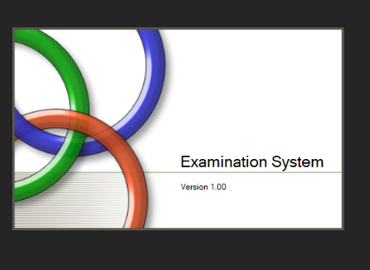

**STARTING PAGE**

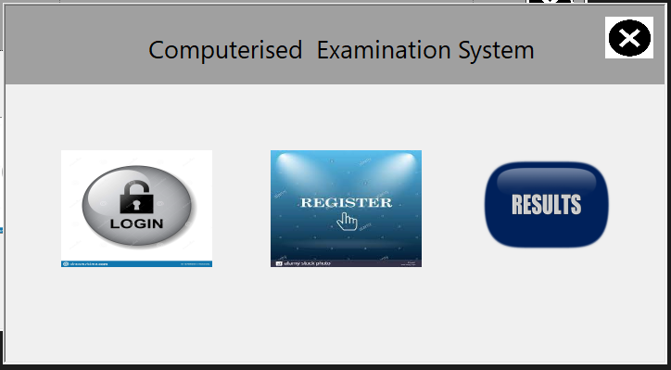

**Login page**

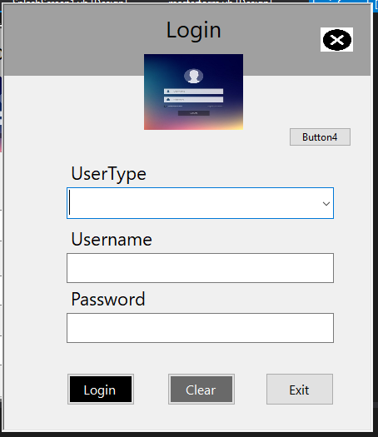

**Registration From For Student**

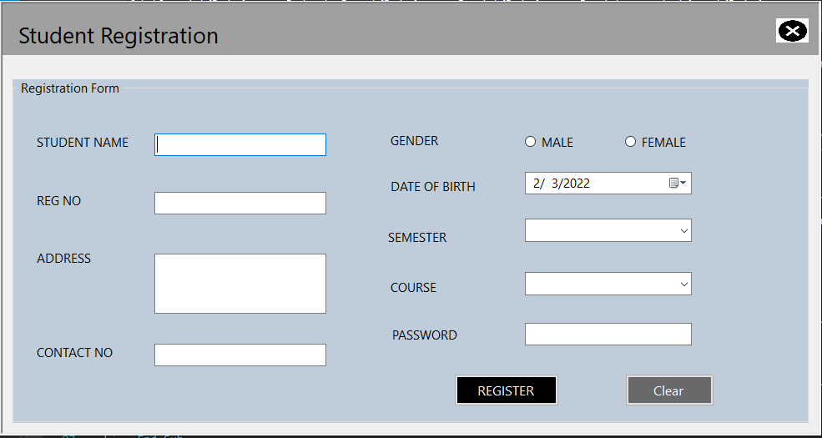

**Dashboard For Teacher**

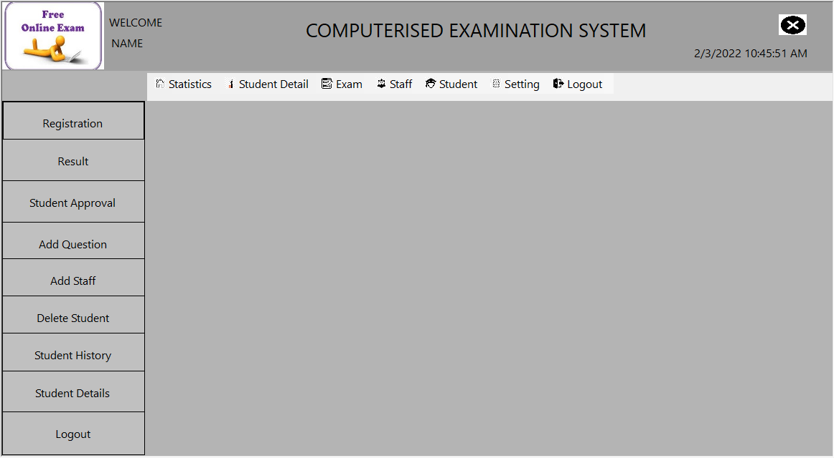

**Student Question Dispalay**

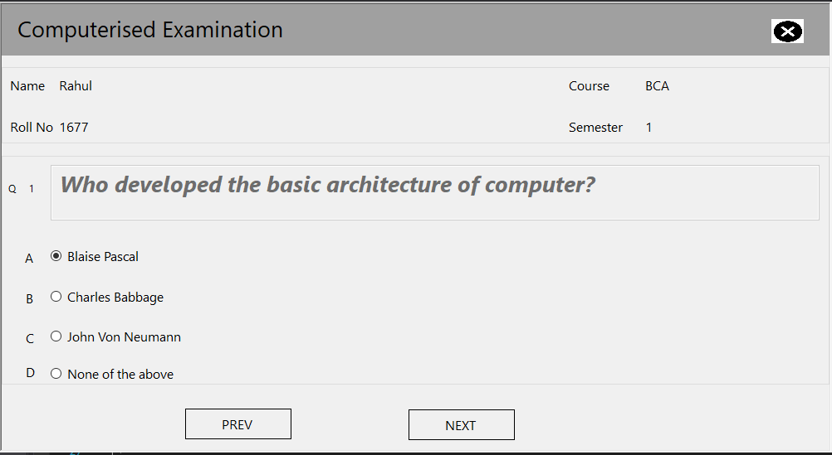

**Display Of Result**

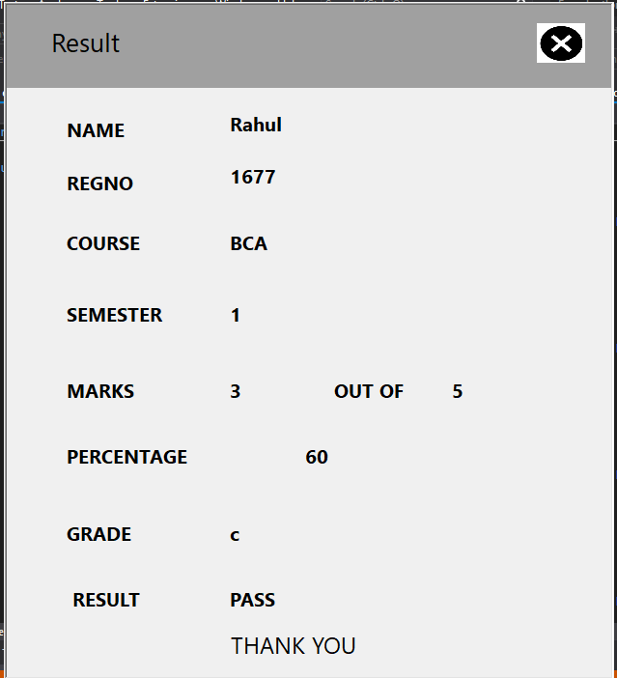

**Adding New Question**

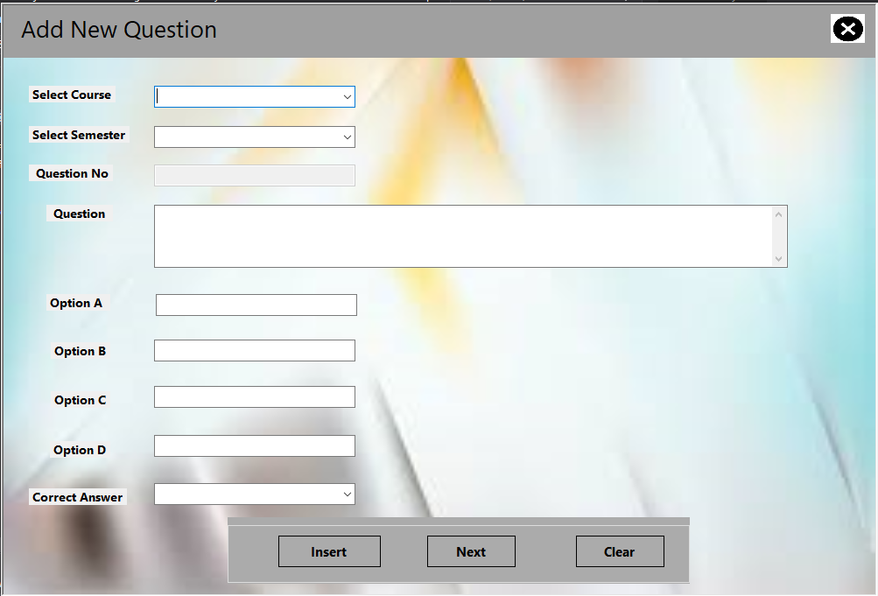

**Adding New Employee**

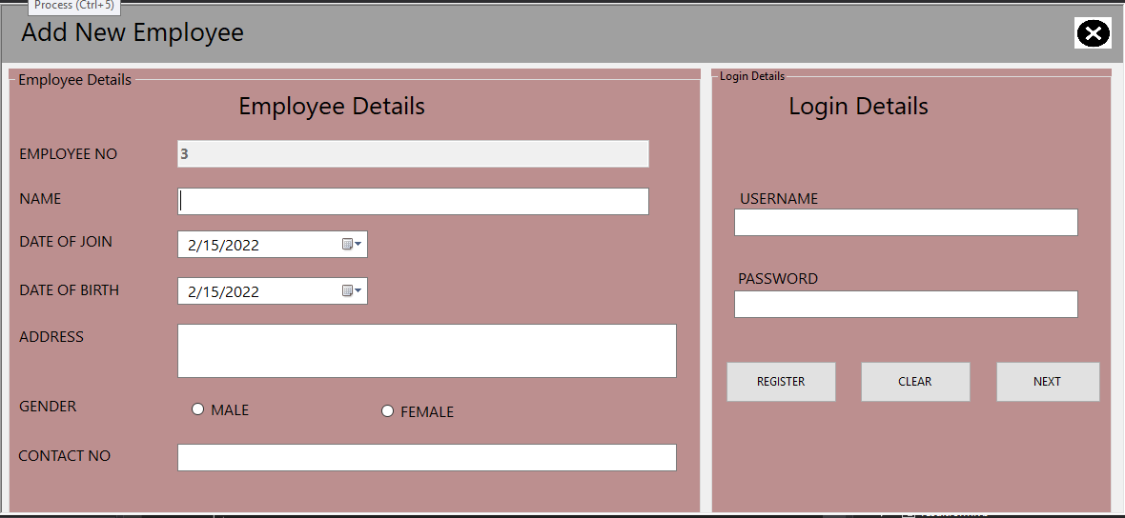

**View Staff list and Updation**

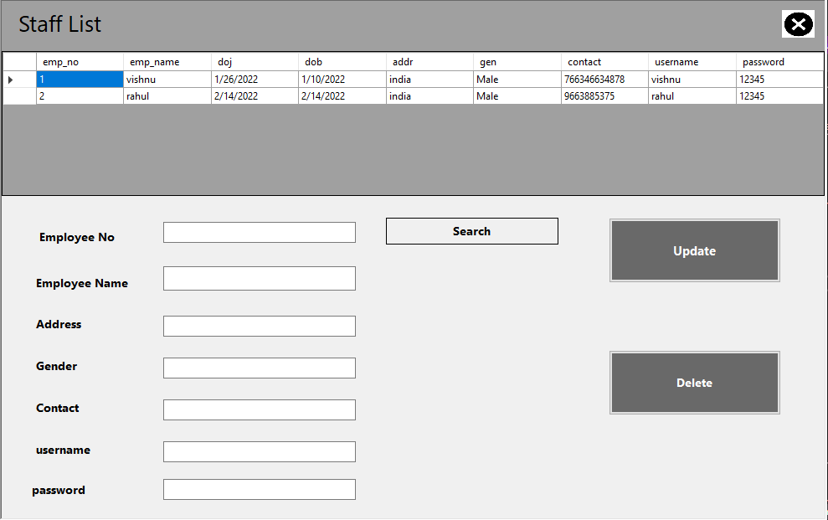

# Source Code’

PLASH SCREEN FRAME CODING

Public NotInheritable Class SplashScreen1

'TODO: This form can easily be set as the splash screen for the application by going to the "Application" tab

' of the Project Designer ("Properties" under the "Project" menu).

Private Sub SplashScreen1_Load(ByVal sender As Object, ByVal e As System.EventArgs) Handles Me.Load

'Set up the dialog text at runtime according to the application's assembly information.

'TODO: Customize the application's assembly information in the "Application" pane of the project

' properties dialog (under the "Project" menu).

'Application title

If My.Application.Info.Title <> "" Then

ApplicationTitle.Text = My.Application.Info.Title

Else

'If the application title is missing, use the application name, without the extension

ApplicationTitle.Text = System.IO.Path.GetFileNameWithoutExtension(My.Application.Info.AssemblyName)

End If

Version.Text = System.String.Format(Version.Text, My.Application.Info.Version.Major, My.Application.Info.Version.Minor)

'Copyright info

Copyright.Text = My.Application.Info.Copyright

**Source Code of First Page**

Public Class Form1

Private Sub PictureBox5_Click(sender As Object, e As EventArgs) Handles PictureBox5.Click

Me.Close()

End Sub

Private Sub PictureBox2_Click(sender As Object, e As EventArgs) Handles PictureBox2.Click

Loginform.Show()

Me.Hide()

End Sub

Private Sub PictureBox3_Click(sender As Object, e As EventArgs) Handles PictureBox3.Click

Registration_Form.Show()

Me.Hide()

End Sub

Private Sub PictureBox4_Click(sender As Object, e As EventArgs) Handles PictureBox4.Click

result2form.Show()

Me.Hide()

End Sub

End Class

**source Code of login page**

Imports System.Data.SqlClient

Public Class Loginform

Dim con As New SqlConnection("Data Source=(LocalDB)\MSSQLLocalDB;AttachDbFilename=C:\Users\dell\Desktop\exam pics\Exam_Database.mdf;Integrated Security=True;Connect Timeout=30")

Dim sqlstr As String

Private Sub Button2_Click(sender As Object, e As EventArgs) Handles Button2.Click

TextBox1.Text = ""

TextBox2.Text = ""

End Sub

Private Sub Button3_Click(sender As Object, e As EventArgs) Handles Button3.Click

Me.Close()

Form1.Show()

End Sub

Private Sub PictureBox1_Click(sender As Object, e As EventArgs) Handles PictureBox1.Click

Me.Close()

End Sub

Private Sub Button1_Click(sender As Object, e As EventArgs) Handles Button1.Click

masterform.writetextboxtolabel(TextBox1.Text)

If Len(Trim(TextBox2.Text)) = 0 Then

MessageBox.Show("Please Enter the Password Correctly", "Input Error", MessageBoxButtons.OK, MessageBoxIcon.Exclamation)

TextBox1.Focus()

Exit Sub

End If

valid()

sqlstr = "select * from password where u_rname ='" & TextBox1.Text & "' And password='" & TextBox2.Text & "' And type='" & ComboBox1.SelectedItem & "'"

con.Open()

Dim cmd As SqlCommand = New SqlCommand(sqlstr, con)

Dim dr1 As SqlDataReader = cmd.ExecuteReader

If dr1.Read Then

Me.Hide()

If ComboBox1.SelectedItem = "Admin" Then

masterform.Show()

ElseIf ComboBox1.SelectedItem = "Student" Then

stu_details.Show()

ElseIf ComboBox1.SelectedItem = "Teacher" Then

masterform.Show()

End If

Else

MessageBox.Show("Entered Username or password is incorrect", "Warning", MessageBoxButtons.OK, MessageBoxIcon.Error)

End If

con.Close()

End Sub

Public Sub valid()

Dim pattern As String = "^[a-zA-Z][\w\.-]*[a-zA-Z0-9]@[a-zA-Z0-9][\w\.-]*[a-zAZ0-9]\.[a-zA-Z][a-zA-Z\.]*[a-zA-Z]$"

If TextBox1.Text = pattern Then

MessageBox.Show("Invalid Character", "Input Error", MessageBoxButtons.OK, MessageBoxIcon.Exclamation)

TextBox1.Focus()

End If

End Sub

Private Sub Button4_Click(sender As Object, e As EventArgs) Handles Button4.Click

masterform.Show()

End Sub

Private Sub ComboBox1_SelectedIndexChanged(sender As Object, e As EventArgs) Handles ComboBox1.SelectedIndexChanged

If ComboBox1.SelectedItem = "Student" Then

Label2.Text = "Regno"

Else

Label2.Text = "Username"

End If

End Sub

**Source Code of login page**

Imports System.Data.SqlClient

Public Class Registration_Form

Dim con_str As String = "Data Source=(LocalDB)\MSSQLLocalDB;AttachDbFilename=C:\Users\dell\Desktop\exam pics\Exam_Database.mdf;Integrated Security=True;Connect Timeout=30"

Dim con As New SqlConnection(con_str)

Dim cmd As New SqlCommand

Dim adapter As New SqlDataAdapter

Dim ap As String = ""

Private Sub PictureBox1_Click(sender As Object, e As EventArgs) Handles PictureBox1.Click

Me.Hide()

Form1.Show()

End Sub

Private Sub Registration_Form_Load(sender As Object, e As EventArgs) Handles MyBase.Load

data()

TextBox2.Focus()

End Sub

Sub data()

con.Open()

Dim sqlstr As String = "select Max(stdno) + 1 from registration"

Dim cmd As SqlCommand = New SqlCommand(Sqlstr, con)

Dim dr1 As SqlDataReader = cmd.ExecuteReader

If dr1.Read Then

ap = IIf(IsDBNull(dr1(0)), 1, dr1(0))

End If

con.Close()

End Sub

Private Sub Button4_Click(sender As Object, e As EventArgs) Handles Button4.Click

If Len(Trim(TextBox2.Text)) = 0 Then

MessageBox.Show("Incomplete information ", "Input Error", MessageBoxButtons.OK, MessageBoxIcon.Exclamation)

TextBox2.Focus()

Exit Sub

End If

If Len(Trim(TextBox3.Text)) = 0 Then

MessageBox.Show("Incomplete information ", "Input Error", MessageBoxButtons.OK, MessageBoxIcon.Exclamation)

TextBox3.Focus()

Exit Sub

End If

If Len(Trim(TextBox4.Text)) = 0 Then

MessageBox.Show("Incomplete information ", "Input Error", MessageBoxButtons.OK, MessageBoxIcon.Exclamation)

TextBox4.Focus()

Exit Sub

End If

If Len(Trim(TextBox5.Text)) = 0 Then

MessageBox.Show("Incomplete information ", "Input Error", MessageBoxButtons.OK, MessageBoxIcon.Exclamation)

TextBox6.Focus()

Exit Sub

End If

If Len(Trim(TextBox6.Text)) = 0 Then

MessageBox.Show("Incomplete information ", "Input Error", MessageBoxButtons.OK, MessageBoxIcon.Exclamation)

TextBox6.Focus()

Exit Sub

End If

Dim gen As String = ""

If RadioButton1.Checked Then

gen = "Male"

ElseIf RadioButton2.Checked Then

gen = "Female"

End If

Dim sqlstr As String = "insert into registration values('" & ap & "','" & TextBox2.Text & "','" & TextBox6.Text & "','" & TextBox3.Text & "','" & TextBox4.Text & "','" & gen & "','" & ComboBox1.SelectedItem & "','" & ComboBox2.SelectedItem & "','" & DateTimePicker1.Value & "','" & "No" & "','" & 0 & "','" & TextBox5.Text & "')"

con.Open()

Dim cmd1 As SqlCommand = New SqlCommand(sqlstr, con)

cmd1.ExecuteNonQuery()

con.Close()

pass()

MessageBox.Show("Student Sucessfully Registered ", " Information", MessageBoxButtons.OK, MessageBoxIcon.Information)

TextBox2.Clear()

TextBox3.Clear()

TextBox4.Clear()

TextBox5.Clear()

TextBox6.Clear()

'TextBox1.Clear()

RadioButton1.Checked = False

RadioButton2.Checked = False

ComboBox1.SelectedIndex = -1

ComboBox2.SelectedIndex = -1

End Sub

Public Sub pass()

Dim s As String = "Student"

Dim sqlstr As String = "insert into password values('" & s & "','" & TextBox6.Text & "','" & TextBox5.Text & "')"

con.Open()

Dim cmd1 As SqlCommand = New SqlCommand(sqlstr, con)

cmd1.ExecuteNonQuery()

con.Close()

End Sub

Private Sub Button3_Click(sender As Object, e As EventArgs) Handles Button3.Click

TextBox2.Clear()

TextBox3.Clear()

TextBox4.Clear()

TextBox6.Clear()

TextBox5.Clear()

RadioButton1.Checked = False

RadioButton2.Checked = False

ComboBox1.SelectedIndex = -1

ComboBox2.SelectedIndex = -1

End Sub

Private Sub TextBox2_KeyPress(sender As Object, e As KeyPressEventArgs) Handles TextBox2.KeyPress

If Not (Asc(e.KeyChar) = 8) Then

Dim allowedChars As String = "abcdefghijklmnopqrstuvwxyz"

If Not allowedChars.Contains(e.KeyChar.ToString.ToLower) Then

e.KeyChar = ChrW(0)

e.Handled = True

End If

End If

End Sub

Private Sub TextBox3_KeyPress(sender As Object, e As KeyPressEventArgs) Handles TextBox3.KeyPress

If Not (Asc(e.KeyChar) = 8) Then

Dim allowedChars As String = "abcdefghijklmnopqrstuvwxyz"

If Not allowedChars.Contains(e.KeyChar.ToString.ToLower) Then

e.KeyChar = ChrW(0)

e.Handled = True

End If

End If

End Sub

Private Sub TextBox6_KeyPress(sender As Object, e As KeyPressEventArgs) Handles TextBox6.KeyPress

If Char.IsDigit(e.KeyChar) = False Then

If e.KeyChar = CChar(ChrW(Keys.Back)) Or e.KeyChar = CChar(ChrW(Keys.Space)) Then

e.Handled = False

Else

e.Handled = True

End If

End If

End Sub

Private Sub TextBox4_KeyPress(sender As Object, e As KeyPressEventArgs) Handles TextBox4.KeyPress

If Char.IsDigit(e.KeyChar) = False Then

If e.KeyChar = CChar(ChrW(Keys.Back)) Or e.KeyChar = CChar(ChrW(Keys.Space)) Then

e.Handled = False

Else

e.Handled = True

End If

End If

End Sub

Private Sub TextBox4_Leave(sender As Object, e As EventArgs) Handles TextBox4.Leave

If (TextBox4.TextLength < 10 Or TextBox4.TextLength > 13) Then

MsgBox("Mobile Number Should Be of 10-13 Digits", MsgBoxStyle.Exclamation, "Warning")

TextBox4.Focus()

End If

End Sub

Private Sub TextBox5_KeyPress(sender As Object, e As KeyPressEventArgs) Handles TextBox5.KeyPress

If Char.IsDigit(e.KeyChar) = False Then

If e.KeyChar = CChar(ChrW(Keys.Back)) Or e.KeyChar = CChar(ChrW(Keys.Space)) Then

e.Handled = False

Else

e.Handled = True

End If

End If

End Sub

Private Sub TextBox5_Leave(sender As Object, e As EventArgs) Handles TextBox5.Leave

If (TextBox5.TextLength < 5 Or TextBox5.TextLength > 10) Then

MsgBox("Password Should Be of 5-10 Digits", MsgBoxStyle.Exclamation, "Warning")

TextBox5.Focus()

End If

End Sub

End Class

**Teacher Dashboard Source Code**

Imports System.Data.SqlClient

Public Class masterform

Dim con As New SqlConnection("DataSource=(LocalDB)\MSSQLLocalDB;AttachDbFilename=C:\Users\dell\Desktop\exam pics\Exam_Database.mdf;Integrated Security=True;Connect Timeout=30")

Private Sub PictureBox1_Click(sender As Object, e As EventArgs) Handles PictureBox1.Click

Me.Close()

Loginform.Show()

End Sub

Private Sub Button1_Click(sender As Object, e As EventArgs) Handles Button1.Click

Registration_Form.Show()

End Sub

Public Sub writetextboxtolabel(ByVal txt As String)

Label3.Text = txt

End Sub

Private Sub masterform_Load(sender As Object, e As EventArgs) Handles MyBase.Load

Label4.Text = DateTime.Now.ToString

End Sub

Private Sub MenuStrip1_ItemClicked(sender As Object, e As ToolStripItemClickedEventArgs) Handles MenuStrip1.ItemClicked

End Sub

Private Sub ApproveToolStripMenuItem_Click(sender As Object, e As EventArgs) Handles ApproveToolStripMenuItem.Click

approvalformstu.Show()

End Sub

Private Sub HistoryToolStripMenuItem_Click(sender As Object, e As EventArgs) Handles HistoryToolStripMenuItem.Click

approvalhistory.Show()

End Sub

Private Sub LogoutToolStripMenuItem_Click(sender As Object, e As EventArgs) Handles LogoutToolStripMenuItem.Click

Me.Close()

Loginform.Show()

End Sub

Private Sub ADDQuestionToolStripMenuItem_Click(sender As Object, e As EventArgs) Handles ADDQuestionToolStripMenuItem.Click

Me.Close()

addquestionform.Show()

End Sub

Private Sub ViewEditToolStripMenuItem_Click(sender As Object, e As EventArgs) Handles ViewEditToolStripMenuItem.Click

edit_update_question.Show()

End Sub

Private Sub AddStaffToolStripMenuItem_Click(sender As Object, e As EventArgs) Handles AddStaffToolStripMenuItem.Click

AddEmployeeForm.Show()

Me.Close()

End Sub

Private Sub ViewStaffToolStripMenuItem_Click(sender As Object, e As EventArgs) Handles ViewStaffToolStripMenuItem.Click

view_employee.Show()

Me.Close()

End Sub

Private Sub ExamPasswordToolStripMenuItem_Click(sender As Object, e As EventArgs) Handles ExamPasswordToolStripMenuItem.Click

forgetPass.Show()

Me.Close()

End Sub

Private Sub Button3_Click(sender As Object, e As EventArgs) Handles Button3.Click

approvalformstu.Show()

End Sub

Private Sub Button4_Click(sender As Object, e As EventArgs) Handles Button4.Click

addquestionform.Show()

End Sub

Private Sub Button5_Click(sender As Object, e As EventArgs) Handles Button5.Click

AddEmployeeForm.Show()

End Sub

Private Sub ChangePasswordToolStripMenuItem_Click(sender As Object, e As EventArgs) Handles ChangePasswordToolStripMenuItem.Click

changepass.Show()

Me.Close()

End Sub

Private Sub Button2_Click(sender As Object, e As EventArgs) Handles Button2.Click

result2form.Show()

Me.Close()

End Sub

Sub delete()

Dim q As String = InputBox("Enter the Registration No ")

If (MsgBox("Do you want to Delete this Student ", vbYesNo + vbQuestion) = vbYes) Then

con.Open()

cmd = New SqlCommand("delete from registration where regno ='" & q & "'", con)

cmd.ExecuteNonQuery()

con.Close()

MsgBox("Student Sucessfully Removed ", vbInformation)

End If

End Sub

Private Sub Button6_Click(sender As Object, e As EventArgs) Handles Button6.Click

delete()

End Sub

Private Sub MasterToolStripMenuItem_Click(sender As Object, e As EventArgs) Handles MasterToolStripMenuItem.Click

student_Details.Show()

'Me.Close()

End Sub

Private Sub Button7_Click(sender As Object, e As EventArgs) Handles Button7.Click

approvalhistory.Show()

' Me.Close()

End Sub

Private Sub Button10_Click(sender As Object, e As EventArgs) Handles Button10.Click

Loginform.Show()

Me.Close()

End Sub

Private Sub Button8_Click(sender As Object, e As EventArgs) Handles Button8.Click

student_Details.Show()

End Sub

Private Sub HomeToolStripMenuItem_Click(sender As Object, e As EventArgs) Handles HomeToolStripMenuItem.Click

Statistics.Show()

End Sub

End Class

**Display of Question Source Code**

Imports System.Data.SqlClient

Public Class examquestion

Dim table As New DataTable

Dim index As Integer

Dim con As New SqlConnection("Data Source=(LocalDB)\MSSQLLocalDB;AttachDbFilename=C:\Users\dell\Desktop\exam pics\Exam_Database.mdf;Integrated Security=True;Connect Timeout=30")

Dim d, diff As TimeSpan

Dim d2 As DateTime

Private Sub examquestion_Load(sender As Object, e As EventArgs) Handles MyBase.Load

con.Open()

Dim sql As String = "select studname,regno,contact_no,gender,course,qualification,approve from registration where regno = '" & r & "'"

Dim cmd As New SqlCommand(sql, con)

Dim myreader As SqlDataReader

myreader = cmd.ExecuteReader

myreader.Read()

Label10.Text = myreader("studname")

Label6.Text = myreader("regno")

Label7.Text = myreader("course")

Label8.Text = myreader("qualification")

Dim se As Integer = myreader("qualification").ToString

con.Close()

con.Open()

Dim sql1 As String = "select qno,question,sem,opA,opB,opC,opD,ans from question where sem ='" & se & "' "

Dim cmd1 As New SqlCommand(sql1, con)

Dim myreader1 As SqlDataReader

myreader1 = cmd1.ExecuteReader

myreader1.Read()

Label11.Text = myreader1("qno")

TextBox1.Text = myreader1("question")

RadioButton1.Text = myreader1("opA")

RadioButton2.Text = myreader1("opB")

RadioButton3.Text = myreader1("opC")

RadioButton4.Text = myreader1("opD")

qnum = myreader1("qno").ToString

se = myreader1("sem").ToString

ans = myreader1("ans").ToString

con.Close()

Dim ca As String = ""

del()

If Label11.Text = 1 Then

marks()

End If

If RadioButton1.Checked = True Then

an = "A"

Dim qry As String = "insert into result values('" & Label6.Text & "','" & Label7.Text & "','" & Label8.Text & "','" & Label11.Text & "','" & ans & "','" & an & "')"

con.Open()

Dim cmd11 As SqlCommand = New SqlCommand(qry, con)

cmd11.ExecuteNonQuery()

con.Close()

ElseIf RadioButton2.Checked = True Then

an = "B"

Dim qry As String = "insert into result values('" & Label6.Text & "','" & Label7.Text & "','" & Label8.Text & "','" & Label11.Text & "','" & ans & "','" & an & "')"

con.Open()

Dim cmd11 As SqlCommand = New SqlCommand(qry, con)

cmd11.ExecuteNonQuery()

con.Close()

ElseIf RadioButton3.Checked = True Then

an = "c"

Dim qry As String = "insert into result values('" & Label6.Text & "','" & Label7.Text & "','" & Label8.Text & "','" & Label11.Text & "','" & ans & "','" & an & "')"

con.Open()

Dim cmd11 As SqlCommand = New SqlCommand(qry, con)

cmd11.ExecuteNonQuery()

con.Close()

ElseIf RadioButton4.Checked = True Then

an = "D"

Dim qry As String = "insert into result values('" & Label6.Text & "','" & Label7.Text & "','" & Label8.Text & "','" & Label11.Text & "','" & ans & "','" & an & "')"

con.Open()

Dim cmd11 As SqlCommand = New SqlCommand(qry, con)

cmd11.ExecuteNonQuery()

con.Close()

End If

End Sub

Private Sub PictureBox1_Click(sender As Object, e As EventArgs) Handles PictureBox1.Click

Me.Close()

Loginform.Show()

End Sub

Private Sub Button2_Click(sender As Object, e As EventArgs) Handles Button2.Click

'marks()

If Label11.Text = 1 Then

marks()

End If

Dim qno As Integer = Val(Label11.Text + 1)

con.Open()

Dim sq As String = "select max(qno) from question where sem ='" & Label8.Text & "'"

Dim cmd As New SqlCommand(sq, con)

Dim q As String = cmd.ExecuteScalar().ToString

If qno = q Then

submitform.Show()

Me.Close()

End If

con.Close()

If RadioButton1.Checked = False And RadioButton2.Checked = False And RadioButton3.Checked = False And RadioButton4.Checked = False Then

MessageBox.Show("Please Select the Answer", "Answer Not Selected ", MessageBoxButtons.OK, MessageBoxIcon.Exclamation)

Else

con.Open()

Dim sql1 As String = "select qno,question,sem,opA,opB,opC,opD,ans from question where sem ='" & sem & "' and qno='" & qno & "' "

Dim cmd1 As New SqlCommand(sql1, con)

Dim myreader1 As SqlDataReader

myreader1 = cmd1.ExecuteReader

myreader1.Read()

Label11.Text = myreader1("qno")

TextBox1.Text = myreader1("question")

RadioButton1.Text = myreader1("opA")

RadioButton2.Text = myreader1("opB")

RadioButton3.Text = myreader1("opC")

RadioButton4.Text = myreader1("opD")

ans = myreader1("ans").ToString

con.Close()

End If

If qno = q Then

Button2.Enabled = False

End If

marks()

End Sub

Private Sub Button1_Click(sender As Object, e As EventArgs) Handles Button1.Click

Dim qno As Integer = Val(Label11.Text - 1)

If qno = 1 Then

Button1.Enabled = False

Button2.Enabled = True

End If

If RadioButton1.Checked = False And RadioButton2.Checked = False And RadioButton3.Checked = False And RadioButton4.Checked = False Then

MessageBox.Show("Please Select the Answer", "Answer Not Selected ", MessageBoxButtons.OK, MessageBoxIcon.Exclamation)

Else

con.Open()

Dim sql1 As String = "select qno,question,sem,opA,opB,opC,opD,ans from question where sem ='" & sem & "' and qno='" & qno & "' "

Dim cmd1 As New SqlCommand(sql1, con)

Dim myreader1 As SqlDataReader

myreader1 = cmd1.ExecuteReader

myreader1.Read()

Label11.Text = myreader1("qno")

TextBox1.Text = myreader1("question")

RadioButton1.Text = myreader1("opA")

RadioButton2.Text = myreader1("opB")

RadioButton3.Text = myreader1("opC")

RadioButton4.Text = myreader1("opD")

ans = myreader1("ans").ToString

con.Close()

End If

End Sub

Public Sub del()

Dim qry1 As String = "delete from result where regno ='" & Label6.Text & "'"

con.Open()

Dim cmd1 As SqlCommand = New SqlCommand(qry1, con)

cmd1.ExecuteNonQuery()

con.Close()

End Sub

Public Sub marks()

If RadioButton1.Checked = True Then

an = "A"

Dim qry As String = "insert into result values('" & Label6.Text & "','" & Label7.Text & "','" & Label8.Text & "','" & Label11.Text & "','" & ans & "','" & an & "')"

con.Open()

Dim cmd11 As SqlCommand = New SqlCommand(qry, con)

cmd11.ExecuteNonQuery()

con.Close()

ElseIf RadioButton2.Checked = True Then

an = "B"

Dim qry As String = "insert into result values('" & Label6.Text & "','" & Label7.Text & "','" & Label8.Text & "','" & Label11.Text & "','" & ans & "','" & an & "')"

con.Open()

Dim cmd11 As SqlCommand = New SqlCommand(qry, con)

cmd11.ExecuteNonQuery()

con.Close()

ElseIf RadioButton3.Checked = True Then

an = "c"

Dim qry As String = "insert into result values('" & Label6.Text & "','" & Label7.Text & "','" & Label8.Text & "','" & Label11.Text & "','" & ans & "','" & an & "')"

con.Open()

Dim cmd11 As SqlCommand = New SqlCommand(qry, con)

cmd11.ExecuteNonQuery()

con.Close()

ElseIf RadioButton4.Checked = True Then

an = "D"

Dim qry As String = "insert into result values('" & Label6.Text & "','" & Label7.Text & "','" & Label8.Text & "','" & Label11.Text & "','" & ans & "','" & an & "')"

con.Open()

Dim cmd11 As SqlCommand = New SqlCommand(qry, con)

cmd11.ExecuteNonQuery()

con.Close()

End If

End Sub

End Class

**Display of Result Source Code**

Imports System.Data.SqlClient

Public Class resultform

Dim sm, tm As Integer

Dim nam, regno, course, semester, marks_scored, total_marks, percentage, grade, result As String

Dim con As New SqlConnection("Data Source=(LocalDB)\MSSQLLocalDB;AttachDbFilename=C:\Users\dell\Desktop\exam pics\Exam_Database.mdf;Integrated Security=True;Connect Timeout=30")

Private Sub resultform_Load(sender As Object, e As EventArgs) Handles MyBase.Load

rr = InputBox("PLEASE ENTER YOUR REGNO")

Dim sqlstr As String = "select regno from result where regno ='" & rr & "'"

con.Open()

Dim cmd As SqlCommand = New SqlCommand(sqlstr, con)

Dim dr1 As SqlDataReader = cmd.ExecuteReader

If dr1.Read Then

Me.Hide()

Else

MessageBox.Show("Entered Regno is incorrect", "Warning", MessageBoxButtons.OK, MessageBoxIcon.Error)

Me.Close()

End

End If

con.Close()

show_details()

show_details_1()

show_details_2()

show_details_3()

show_details_4()

fresult()

End Sub

Public Sub show_details()

con.Open()

Dim sql As String = "select studname,regno from registration where regno = '" & rr & "'"

Dim cmd As New SqlCommand(sql, con)

Dim myreader As SqlDataReader

myreader = cmd.ExecuteReader

myreader.Read()

Label24.Text = myreader("studname")

nam = myreader("studname").ToString

Label3.Text = myreader("regno")

regno = myreader("regno").ToString

con.Close()

End Sub

Public Sub fshow()

con.Open()

Dim sql As String = "select name,regno,course,semester,marks_scored,total_marks,percentage,grade,result from f_result where regno = '" & rr & "'"

Dim cmd As New SqlCommand(sql, con)

Dim myreader As SqlDataReader

myreader = cmd.ExecuteReader

myreader.Read()

End Sub

Public Sub show_details_1()

con.Open()

Dim sql As String = "select course,sem from result where regno = '" & rr & "'"

Dim cmd As New SqlCommand(sql, con)

Dim myreader As SqlDataReader

myreader = cmd.ExecuteReader

myreader.Read()

Label5.Text = myreader("course")

course = myreader("course").ToString

Label7.Text = myreader("sem")

semester = myreader("sem").ToString

con.Close()

End Sub

Public Sub show_details_2()

con.Open()

Dim sql As String = "select count(*)as aa from result where crc_ans=answer and regno = '" & rr & "'"

Dim cmd As New SqlCommand(sql, con)

Dim myreader As SqlDataReader

myreader = cmd.ExecuteReader

myreader.Read()

Label9.Text = myreader("aa").ToString

sm = myreader("aa").ToString

marks_scored = myreader("aa").ToString

con.Close()

End Sub

Public Sub show_details_3()

con.Open()

Dim sql As String = "select count(*)as tq from result where regno = '" & rr & "'"

Dim cmd As New SqlCommand(sql, con)

Dim myreader As SqlDataReader

myreader = cmd.ExecuteReader

myreader.Read()

Label11.Text = myreader("tq").ToString

tm = myreader("tq").ToString

total_marks = myreader("tq").ToString

con.Close()

End Sub

Public Sub show_details_4()

Dim avg As Integer

avg = sm / tm * 100

Label26.Text = avg

percentage = Label26.Text

'Dim grade As String

If avg > 90 Then

Label13.Text = "A+"

grade = "A+"

Label15.Text = "PASS"

ElseIf avg >= 90 Then

Label13.Text = "A"

grade = "A"

Label15.Text = "PASS"

ElseIf avg >= 80 Then

Label13.Text = "B+"

grade = "B+"

Label15.Text = "PASS"

ElseIf avg >= 70 Then

Label13.Text = "B"

grade = "B"

Label15.Text = "PASS"

ElseIf avg >= 60 Then

Label13.Text = "c"

grade = "C"

Label15.Text = "PASS"

Else

Label13.Text = "c"

grade = "C"

Label15.Text = "FAIL"

End If

result = Label15.Text

End Sub

Public Sub fresult()

con.Open()

Dim qry As String = "insert into f_result values('" & nam & "','" & regno & "','" & course & "','" & semester & "','" & marks_scored & "','" & total_marks & "','" & percentage & "','" & grade & "','" & result & "')"

Dim cmd1 As SqlCommand = New SqlCommand(qry, con)

cmd1.ExecuteNonQuery()

con.Close()

End Sub

Private Sub PictureBox2_Click(sender As Object, e As EventArgs) Handles PictureBox2.Click

Me.Close()

Form1.Show()

End Sub

End Class

**Adding Question**

Imports System.Data.SqlClient

Public Class addquestionform

Dim con As New SqlConnection("Data Source=(LocalDB)\MSSQLLocalDB;AttachDbFilename=C:\Users\dell\Desktop\exam pics\Exam_Database.mdf;Integrated Security=True;Connect Timeout=30")

Private Sub PictureBox1_Click(sender As Object, e As EventArgs) Handles PictureBox1.Click

Me.Close()

masterform.Show()

End Sub

Private Sub Button1_Click(sender As Object, e As EventArgs) Handles Button1.Click

If ComboBox1.Text.Trim() = "" Then

MessageBox.Show("Please Select the Course ", "Input Error", MessageBoxButtons.OK, MessageBoxIcon.Exclamation)

TextBox5.Focus()

Exit Sub

End If

If ComboBox2.Text.Trim() = "" Then

MessageBox.Show("Please select the Semester ", "Input Error", MessageBoxButtons.OK, MessageBoxIcon.Exclamation)

TextBox5.Focus()

Exit Sub

End If

If ComboBox3.Text.Trim() = "" Then

MessageBox.Show("Please Select the Correct Answer ", "Input Error", MessageBoxButtons.OK, MessageBoxIcon.Exclamation)

TextBox5.Focus()

Exit Sub

End If

If Len(Trim(TextBox1.Text)) = 0 Then

MessageBox.Show("Incomplete information ", "Input Error", MessageBoxButtons.OK, MessageBoxIcon.Exclamation)

TextBox1.Focus()

Exit Sub

End If

If Len(Trim(TextBox2.Text)) = 0 Then

MessageBox.Show("Incomplete information ", "Input Error", MessageBoxButtons.OK, MessageBoxIcon.Exclamation)

TextBox2.Focus()

Exit Sub

End If

If Len(Trim(TextBox3.Text)) = 0 Then

MessageBox.Show("Incomplete information ", "Input Error", MessageBoxButtons.OK, MessageBoxIcon.Exclamation)

TextBox3.Focus()

Exit Sub

End If

If Len(Trim(TextBox4.Text)) = 0 Then

MessageBox.Show("Incomplete information ", "Input Error", MessageBoxButtons.OK, MessageBoxIcon.Exclamation)

TextBox4.Focus()

Exit Sub

End If

If Len(Trim(TextBox5.Text)) = 0 Then

MessageBox.Show("Incomplete information ", "Input Error", MessageBoxButtons.OK, MessageBoxIcon.Exclamation)

TextBox5.Focus()

Exit Sub

End If

If Len(Trim(TextBox6.Text)) = 0 Then

MessageBox.Show("Incomplete information ", "Input Error", MessageBoxButtons.OK, MessageBoxIcon.Exclamation)

TextBox6.Focus()

Exit Sub

End If

con.Open()

Dim sc As String = ComboBox1.SelectedItem.ToString

Dim sem As String = ComboBox2.SelectedItem.ToString

Dim ans As String = ComboBox3.SelectedItem.ToString

Dim Sql As String = "insert into question values('" & TextBox1.Text & "','" & sc & "','" & sem & "','" & TextBox2.Text & "','" & TextBox3.Text & "','" & TextBox4.Text & "','" & TextBox5.Text & "','" & TextBox6.Text & "','" & ans & "')"

Dim cmd As New SqlCommand(Sql, con)

cmd.ExecuteNonQuery()

MessageBox.Show("Question Added SucessFully .... ", "SuccesssFull", MessageBoxButtons.OK, MessageBoxIcon.Information)

con.Close()

TextBox1.Text = ""

TextBox2.Text = ""

TextBox3.Text = ""

TextBox4.Text = ""

TextBox5.Text = ""

TextBox6.Text = ""

ComboBox1.SelectedIndex = -1

ComboBox2.SelectedIndex = -1

ComboBox3.SelectedIndex = -1

End Sub

Public Sub clear()

TextBox1.Clear()

TextBox2.Clear()

TextBox3.Clear()

TextBox4.Clear()

TextBox5.Clear()

TextBox6.Clear()

ComboBox1.SelectedIndex = -1

ComboBox2.SelectedIndex = -1

ComboBox3.SelectedIndex = -1

End Sub

Public Sub qstno()

con.Open()

Dim sqlstr As String = " select Max(qno) + 1 from question where course ='" & ComboBox1.SelectedItem & "' and sem='" & ComboBox2.SelectedItem & "' "

Dim cmd As SqlCommand = New SqlCommand(sqlstr, con)

Dim dr1 As SqlDataReader = cmd.ExecuteReader

If dr1.Read Then

TextBox1.Text = IIf(IsDBNull(dr1(0)), 1, dr1(0))

End If

con.Close()

End Sub

Private Sub Button4_Click(sender As Object, e As EventArgs) Handles Button4.Click

clear()

End Sub

Private Sub ComboBox2_SelectedIndexChanged(sender As Object, e As EventArgs) Handles ComboBox2.SelectedIndexChanged

qstno()

End Sub

Private Sub Button3_Click(sender As Object, e As EventArgs) Handles Button3.Click

clear()

qstno()

End Sub

End Class

**Adding Staffs Code**

Imports System.Data.SqlClient

Public Class AddEmployeeForm

Dim con As New SqlConnection("Data Source=(LocalDB)\MSSQLLocalDB;AttachDbFilename=C:\Users\dell\Desktop\exam pics\Exam_Database.mdf;Integrated Security=True;Connect Timeout=30")

Private Sub PictureBox1_Click(sender As Object, e As EventArgs) Handles PictureBox1.Click

Me.Close()

masterform.Show()

End Sub

Public Sub empno()

con.Open()

Dim sqlstr As String = " select Max(emp_no) + 1 from employee "

Dim cmd As SqlCommand = New SqlCommand(sqlstr, con)

Dim dr1 As SqlDataReader = cmd.ExecuteReader

If dr1.Read Then

TextBox1.Text = IIf(IsDBNull(dr1(0)), 1, dr1(0))

End If

con.Close()

End Sub

Private Sub AddEmployeeForm_Load(sender As Object, e As EventArgs) Handles MyBase.Load

empno()

End Sub

Private Sub TextBox2_KeyPress(sender As Object, e As KeyPressEventArgs) Handles TextBox2.KeyPress

If Not (Asc(e.KeyChar) = 8) Then

Dim allowedChars As String = "abcdefghijklmnopqrstuvwxyz"

If Not allowedChars.Contains(e.KeyChar.ToString.ToLower) Then

e.KeyChar = ChrW(0)

e.Handled = True

End If

End If

End Sub

Private Sub TextBox3_KeyPress(sender As Object, e As KeyPressEventArgs) Handles TextBox3.KeyPress

If Not (Asc(e.KeyChar) = 8) Then

Dim allowedChars As String = "abcdefghijklmnopqrstuvwxyz"

If Not allowedChars.Contains(e.KeyChar.ToString.ToLower) Then

e.KeyChar = ChrW(0)

e.Handled = True

End If

End If

End Sub

Private Sub TextBox4_KeyPress(sender As Object, e As KeyPressEventArgs) Handles TextBox4.KeyPress

If Char.IsDigit(e.KeyChar) = False Then

If e.KeyChar = CChar(ChrW(Keys.Back)) Or e.KeyChar = CChar(ChrW(Keys.Space)) Then

e.Handled = False

Else

e.Handled = True

End If

End If

End Sub

Private Sub TextBox4_Leave(sender As Object, e As EventArgs) Handles TextBox4.Leave

If (TextBox4.TextLength < 10 Or TextBox4.TextLength > 13) Then

MsgBox("Mobile Number Should Be of 10-13 Digits", MsgBoxStyle.Exclamation, "Warning")

TextBox4.Focus()

End If

End Sub

Private Sub Button1_Click(sender As Object, e As EventArgs) Handles Button1.Click

If Len(Trim(TextBox3.Text)) = 0 Then

MessageBox.Show("Incomplete information ", "Input Error", MessageBoxButtons.OK, MessageBoxIcon.Exclamation)

TextBox3.Focus()

Exit Sub

End If

If Len(Trim(TextBox4.Text)) = 0 Then

MessageBox.Show("Incomplete information ", "Input Error", MessageBoxButtons.OK, MessageBoxIcon.Exclamation)

TextBox4.Focus()

Exit Sub

End If

If Len(Trim(TextBox5.Text)) = 0 Then

MessageBox.Show("Incomplete information ", "Input Error", MessageBoxButtons.OK, MessageBoxIcon.Exclamation)

TextBox5.Focus()

Exit Sub

End If

If Len(Trim(TextBox6.Text)) = 0 Then

MessageBox.Show("Incomplete information ", "Input Error", MessageBoxButtons.OK, MessageBoxIcon.Exclamation)

TextBox5.Focus()

Exit Sub

End If

If RadioButton1.Checked = False And RadioButton2.Checked = False Then

MessageBox.Show("Incomplete information ", "Input Error", MessageBoxButtons.OK, MessageBoxIcon.Exclamation)

End If

Dim gen As String = ""

If RadioButton1.Checked = True Then

gen = "Male"

ElseIf RadioButton2.Checked = True Then

gen = "Female"

End If

Dim sqlstr As String = "insert into employee values('" & TextBox1.Text & "','" & TextBox2.Text & "','" & DateTimePicker1.Value & "','" & DateTimePicker2.Value & "','" & TextBox3.Text & "','" & gen & "','" & TextBox4.Text & "','" & TextBox5.Text & "','" & TextBox6.Text & "')"

con.Open()

Dim cmd1 As SqlCommand = New SqlCommand(sqlstr, con)

cmd1.ExecuteNonQuery()

con.Close()

pass()

MessageBox.Show("Sucessfully added New Employee ", "Sucessfully", MessageBoxButtons.OK, MessageBoxIcon.Information)

RadioButton1.Checked = False

RadioButton2.Checked = False

End Sub

Public Sub pass()

Dim s As String = "Admin"

Dim sqlstr As String = "insert into password values('" & s & "','" & TextBox5.Text & "','" & TextBox6.Text & "')"

con.Open()

Dim cmd1 As SqlCommand = New SqlCommand(sqlstr, con)

cmd1.ExecuteNonQuery()

con.Close()

End Sub

Private Sub TextBox5_KeyPress(sender As Object, e As KeyPressEventArgs) Handles TextBox5.KeyPress

If Not (Asc(e.KeyChar) = 8) Then

Dim allowedChars As String = "abcdefghijklmnopqrstuvwxyz"

If Not allowedChars.Contains(e.KeyChar.ToString.ToLower) Then

e.KeyChar = ChrW(0)

e.Handled = True

End If

End If

End Sub

End Class

Imports System.Data.SqlClient

Public Class view_employee

Dim con As New SqlConnection("Data Source=(LocalDB)\MSSQLLocalDB;AttachDbFilename=C:\Users\dell\Desktop\exam pics\Exam_Database.mdf;Integrated Security=True;Connect Timeout=30")

Private Sub view_employee_Load(sender As Object, e As EventArgs) Handles MyBase.Load

loadgrid()

End Sub

Public Sub loadgrid()

Dim Sql As String = "Select * from employee"

Dim cmd As New SqlCommand(Sql, con)

Dim da As New SqlDataAdapter(cmd)

Dim dt As New DataTable

da.Fill(dt)

DataGridView1.DataSource = dt

End Sub

Private Sub Button3_Click(sender As Object, e As EventArgs) Handles Button3.Click

If Len(Trim(TextBox1.Text)) = 0 Then

MessageBox.Show("Please Type the Employee Number ", "Input Error", MessageBoxButtons.OK, MessageBoxIcon.Exclamation)

TextBox1.Focus()

Exit Sub

End If

con.Open()

Dim sql As String = "select emp_name,addr,gen,contact,username,password from employee where emp_no = '" & TextBox1.Text & "'"

Dim cmd As New SqlCommand(sql, con)

Dim myreader As SqlDataReader

myreader = cmd.ExecuteReader

myreader.Read()

TextBox2.Text = myreader("emp_name")

TextBox3.Text = myreader("addr")

TextBox4.Text = myreader("gen")

TextBox5.Text = myreader("contact")

TextBox6.Text = myreader("username")

TextBox7.Text = myreader("password")

con.Close()

End Sub

Private Sub Button2_Click(sender As Object, e As EventArgs) Handles Button2.Click

Dim q As Integer = InputBox("Please Enter the Question No ")

If (MsgBox("Do you want to Delete this Question ", vbYesNo + vbQuestion) = vbYes) Then

con.Open()

cmd = New SqlCommand("delete employee where emp_no ='" & q & "'", con)

cmd.ExecuteNonQuery()

con.Close()

MsgBox("Employee Sucessfully Removed ", vbInformation)

loadgrid()

TextBox1.Text = ""

TextBox2.Text = ""

TextBox3.Text = ""

TextBox4.Text = ""

TextBox5.Text = ""

TextBox6.Text = ""

TextBox7.Text = ""

End If

End Sub

End Class

**Advantages of “Computerized** **Examination System”**

A Computerized examination system has plenty of advantages:

1. **It saves paper.**

 You never have to print an exam for your students and hand them out. Saves paper. Saves trees. Everybody is happy.

1. **It saves time.**

You can set up an exam in such a way that it will auto-grade itself. If you only use multiple-choice questions you never have to check an exam again. The computerized exam system will take care of that hassle. Completely automated.

1. **It saves more time.**

The distribution of the exam doesn’t take you any time. Just upload the email addresses of your students and send them an invite. And after the exam, they get their result instantly.

1. **It saves you money.**

You don't need to buy any paper. Sending an email is free. On top of that, you save on the logistics: your students don't have to assemble in the classroom to take the exam.

They can do it within a given time frame from their device. You don't have to rent a classroom. You don't have to hire someone to check the students taking the exam.

1. **It saves the student money.**

Students don't have to travel to a specific location to conduct the exam. So even for students from remote areas, it's possible to take the exam.

1. **It's more secure.**

You can make a big question bank with a lot of questions. Every student gets a random selection from that question bank. So it's of little use to share the questions among the exam takers to give them a head start

**FUTURE SCOPE :**

The existing system is limited with few modules and not easy to access the student details and details of the examination.

But our purpose system provides the student details and results of the student adding of question and appropriately updating them.

The computerized system can be used in private institutions as well as educational institutions. As it is a user-friendly web-based application it can be used anywhere and anytime. Every software may have some cases of bugs. Students may use private equipment – computers to write -in-class examinations.

 Computerized examination saves your money in so many ways. Since everything is computerized, there are no printing costs and no logistics costs. Pen-paper examinations require a lot of paper to print question and answer sheets. There is also a lot of waste due to printing errors or over-estimation of learner numbers, not to mention the carbon footprint of the logistics around getting the papers to and from examination locations.

            In the past, the more people who took an exam, the bigger the challenge to facilitate it. Computerized examinations make it super easy to scale. Setting up an exam for 1,000 people takes almost the same amount of effort as it is to set up an exam for 10 people. Another advantage of the tech-centric nature of computerized exams is that the more computerized exams people take, the more they get used to the concept and the more comfortable they get with it.

Security has always been a challenge with exams, especially with high-profile exams like bar exams, SATs, college, and university final exams. With online exams, there are fewer chances of leaks since there are no physical papers that can go missing during the printing and logistics process. An added security benefit is that examiners can make use of question banks that select questions at random. This means that almost no two exams are the same, further minimizing the chances of cheating. One of the biggest advantages of computerized examinations is the convenience factor. Examiners can set papers using question banks, and by consulting a database of previous papers, then easily upload it to the examination system. Students can select exam times that suit them best and since the exams are online, do it from almost anywhere (proctored exams may have certain requirements). Students can get their results almost immediately, a big plus. Also, as mentioned above, online examinations scale extremely easily, making it convenient for course administrators to set up exams.

**CONCLUSION :**

The purpose of the computerized examination system is to test the subject knowledge of the students.Such a system eliminates the logistical hassle and drawbacks in the traditional model of the pen–and–paper examination.As they are convenient, they offer flexibility. They bring the right education to your home. They offer more individual attention. Computerized examination systems help students meet interesting people. It gives students real-world skills. In communication,

The computerized examination is kind of beneficial to the students, tutors and the institution offering. As of now most of the competitive examinations are online, so it is necessary since this method of computerized examination is the only option.

A computerized examination system is a user-friendly system, which is very easy and convenient to use. The system is complete in the sense that it is operational and is tested by entering data and getting the reports in proper order. But there is always a scope for improvement and enhancement.the constant evolution of technology in the digital world has caused a wave of consolidation in the assessment industry, making pen and paper tests redundant. It has bought a patent clarity that online examination conducted with the help of online exam software is the future of assessment methodology. “Future of Computerized Examination System”

The growth of the online industry at a fast pace and obsoleteness of traditional evaluation techniques is making people lose confidence in the current pen-paper examinations.

Today’s article will discuss the future of online examination possible through an online examination system. In this article, we are mentioning the reasons that have dwindled educational institutions' assurance in the conventional evaluation system and the numerous benefits that arise from transitioning to computer-based evaluation.

Before proceeding, let us understand the concept of an online examination system that clothes online computer tests. An online examination software is software that makes conducting of test possible through a computer network and the internet.

educational institutions losing their confidence in pen and paper-based modes of assessment.

Technology has embraced the educational sector in such a manner that it has left no space for pen-paper. The spirit of schools, colleges, universities, and training institutes have withered in the traditional model of assessment due to the following reasons :

● the abundance of entrance examination applications: Universities every year have to incur costs for screening the received abundant application with written tests. Shortlisting facilities to conduct physical tests consumes lots of effort and making space for exam centers disrupts the college life of students.

● the fuss of staff recruitment: Arranging invigilators, and conducting an interview, for choosing teachers to assess the pen-paper examination, is another herculean requirement of this assessment pedagogy.

● improper assessment competencies: The conventional mode of examination is devoid of a definitive way to measure children’s ability and personality. This method disables the teachers to precisely tell the students about their behavioral and cognitive competencies. accrued benefits that arise from transitioning to computer-based evaluation: ranging from a school, university, training institute to a corporation running certification programs or assessing training effectiveness.

Computerized examinations provided by the online examination system are being welcomed with open arms by both the exam candidates as well as the organization providing an assessment.

● reduced administrative burden: Printing and circulating question papers and organizing logistics to transport completed scripts to makers is a time-consuming and costly process. On the other hand, organizing and running exams online reduces the organization’s administrative burden and also saves time and cost.

**BIBLIOGRAPHY**

**REFERENCES**

* + [www.w3schools.com](http://www.w3schools.com)
  + [www.guru99.com](http://www.guru99.com)
  + [www.roseindia.net](http://www.roseindia.net)